16.265 Logic Design Laboratory Grade Sheet

This page should be stapled together with the rest of the report. After the grading, this page will be taken and kept by the TAs for the record.

- (This section to be completed by student)

Student logic number: 146
Student name: (Last) PHONG, (first) VO
Experiment number: 3
Date/time: 3 / 27 / 2018, 17:00

- Preliminary checking
- Is the report written on 8½” x 11” paper and stapled at left margin?
- Is a cover page included?
- Is the report written using the given template?
- Is the correct assignment used in design?

Report will not be accepted if the answer is “NO” to any of the above questions.

- Grade
1. Design procedures: supporting theory, details, etc. (20) ___________
23. Is design correct? (60) ___________
3. Minimization of design (10) ___________
5. List of ICs and unused gates (10) ___________

Gross grade (100) __________

- Adjustment to grade
1. Grade sheet, cover page (−5) ___________
2. Title box of schematic diagram (−5) ___________
3. Schematic diagram in correct format (−10) ___________
4. Misrepresentation of test (simulation) results (−30) ___________
- 5. Neatness and legibility (−10) __________
- 6. Templates (−20) __________

Final grade (100) __________

Comments: ___________________________________________________________________________
_____________________________________________________________________________________

Grader: _________________________ Date: ____/____/________

16.265 Logic Design
Student Logic Number | 146
Name | PHONG VO
E-mail address (print) | Phong_Vo@student.uml.edu
Experiment Number | 3
Date | 03 / 27 / 2018

For grader use
Schematic diagram submitted is different from the one in the report. (Need to re-submit the schematic diagram in the report or will be graded based on a maximum of 50 points.) | 5 points deduction
Cannot open file
File is not readable

Date student is notified to re-submit a schematic file by e-mail
Date schematic file received

Report will be graded based on a maximum of 50 (out of 100 points) if a schematic diagram is not received within three calendar days of notification or the re-submitted schematic file still cannot be opened or is not readable.

Grade: ___________
Experiment 3 Design with Decoders and Multiplexers

- Function Set Assignment

Function set number __9__

F₁(x,y,z) = 1x’y z’ = x’y z

F₂(x,y,z) = xyz’xy’z

F₃(w,x,y,z) = y’(w + xz) + y(wxz + w’x’z’)

F₄(w,x,y,z) = ∑m(1,2,6,7,8,14) + d(9,10,12,13)

F₅(w,x,y,z) = (w’+y)(x’+y+z’)(w+x+y’)(w+y’+z)

2. Design Procedures

Express all the functions in minterm list form

F₁(x,y,z) = Σm (1,2,5,7)

F₂(x,y,z) = Σm (0,3,6)

F₃(w,x,y,z) = Σm (2,5,8,9,12,13,15)

F₄(w,x,y,z) = Σm (1,2,6,7,8,14) + d(9,10,12,13)

F₅(w,x,y,z) = Σm (0,1,4,7,10,11,14,15)

Design for F₁ and F₂
(Show the implementation of F₁ and F₂ by a 74155 IC and some external gates. Draw a circuit diagram.)
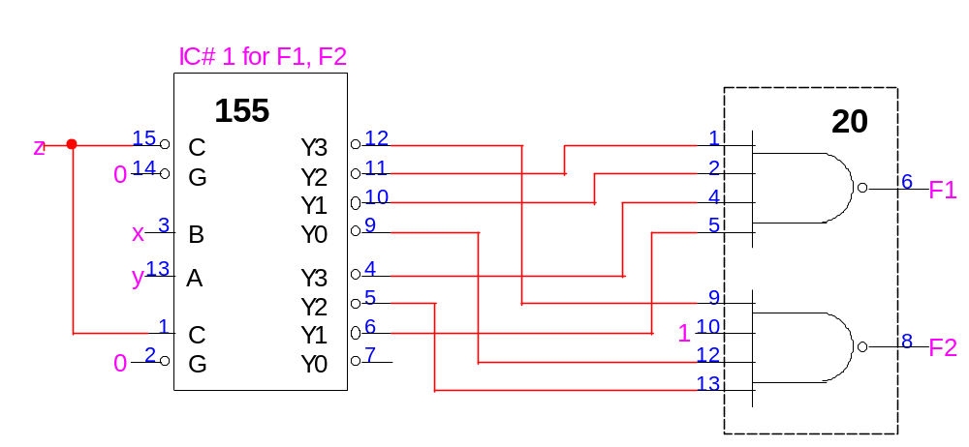
Design for F₃

Draw the sub-function K-maps for F₃ with w, x, z as expansion variables.

y
0
1
F_{wxz = 001}
F_{wxz = 000}
F_{wxz = 010}
F_{wxz = 011}
F_{wxz =100}
F_{wxz = 101}
F_{wxz =110}
0
0
F_{wxz = 111}
0
0
1
0
1
0
1
0
1
0
1
1
0
1

Based on the sub-function K-maps, the data inputs to the 8-to-1 multiplexers are as follows:

I₀ = y
I₁ = 0
I₂ = 0
I₃ = y’
I₄ = y’
I₅ = y’
I₆ = y’
I₇ = 1

_{Design for F4 and F}5
wx yz | 00 | 01 | 11 | 10
00 | 0 | 0 | d | 1
01 | 1 | 0 | d | d
11 | 0 | 1 | 0 | 0
10 | 1 | 1 | 1 | d
K-map for F₄

wx yz | 00 | 01 | 11 | 10
00 | 1 | 1 | 0 | 0
01 | 1 | 0 | 0 | 0
11 | 0 | 1 | 1 | 1
10 | 0 | 0 | 1 | 1
K-map for F₅

(i) Partition the K-maps with w and x as control signals.
wx yz | 00 | 01 | 10 | 11
00 | 0 | 0 | 1 | d
01 | 1 | 0 | d | d
11 | 0 | 1 | 0 | 0
10 | 1 | 1 | d | 1
 | I₀ | I₁ | I₂ | I₃
F₄

wx yz | 00 | 01 | 10 | 11
00 | 1 | 1 | 0 | 0
01 | 1 | 0 | 0 | 0
11 | 0 | 1 | 1 | 1
10 | 0 | 0 | 1 | 1
 | I₀ | I₁ | I₂ | I₃
F₅

The data inputs are as follows:
For F₄ For F₅
I₀ = y’z + yz’= yz I₀ = y’
I₁ = y I₁ = yz + y’z’ = y’ z
I₂ = y’ + z’ I₂ = y
I₃ = y’ + z’ I₃ = y

- Partition the K-maps with w and y as control signals.
wy xz | 00 | 01 | 10 | 11
00 | 0 | 1 | 1 | d
01 | 1 | 0 | d | 0
11 | 0 | 1 | d | 0
10 | 0 | 1 | d | 1
 | I₀ | I₁ | I₂ | I₃
F₄
wy xz | 00 | 01 | 10 | 11
00 | 1 | 0 | 0 | 1
01 | 1 | 0 | 0 | 1
11 | 0 | 1 | 0 | 1
10 | 1 | 0 | 0 | 1
 | I₀ | I₁ | I₂ | I₃
F₅
The data inputs are as follows:

For F₄ For F₅
I₀ = x’z I₀ = x’ + z’
I₁ = x + z’ I₁ = xz
I₂ = 1 I₂ = 0
I₃ = z’ I₃ = 1

- Partition the K-maps with w and z as control signals.
wz xy | 00 | 01 | 10 | 11
00 | 0 | 1 | 1 | d
01 | 1 | 0 | d | 0
11 | 1 | 1 | 1 | 0
10 | 0 | 0 | d | d
 | I₀ | I₁ | I₂ | I₃
_{F4}
wz xy | 00 | 01 | 10 | 11
00 | 1 | 1 | 0 | 0
01 | 0 | 0 | 1 | 1
11 | 0 | 1 | 1 | 1
10 | 1 | 0 | 0 | 0
 | I₀ | I₁ | I₂ | I₃
F₅
The data inputs are as follows:

For F₄ For F₅
I₀ = y I₀ = y’
I₁ = x’y’ + xy = x’ y I₁ = x’y’ + xy = x’ y
I₂ = 1 I₂ = y
I₃ = 0 I₃ = y
(iv) Partition the K-maps with x and y as control signals.
xy wz | 00 | 01 | 10 | 11
00 | 0 | 1 | 0 | 1
01 | 1 | 0 | 0 | 1
11 | d | 0 | d | 0
10 | 1 | d | d | 1
 | I₀ | I₁ | I₂ | I₃
F₄
xy wz | 00 | 01 | 10 | 11
00 | 1 | 0 | 1 | 0
01 | 1 | 0 | 0 | 1
11 | 0 | 1 | 0 | 1
10 | 0 | 1 | 0 | 1
 | I₀ | I₁ | I₂ | I₃
F₅
The data inputs are as follows:

For F₄ For F₅
I₀ = w + z I₀ = w’
I₁ = z’ I₁ = w
I₂ = 0 I₂ = w’z’
I₃ = w’ + z’ I₃ = w + z

(v) Partition the K-maps with x and z as control signals.
xz wy | 00 | 01 | 10 | 11
00 | 0 | 1 | 0 | 0
01 | 1 | 0 | 1 | 1
11 | d | 0 | 1 | 0
10 | 1 | d | d | d
 | I₀ | I₁ | I₂ | I₃
F₄
xz wy | 00 | 01 | 10 | 11
00 | 1 | 1 | 1 | 0
01 | 0 | 0 | 0 | 1
11 | 1 | 1 | 1 | 1
10 | 0 | 0 | 0 | 0
 | I₀ | I₁ | I₂ | I₃
F₅
The data inputs are as follows:

For F₄ For F₅
I₀ = w + y I₀ = wy + w’y’ = w’ y
I₁ = y’ I₁ = wy + w’y’ = w’ y
I₂ = w + y I₂ = wy + w’y’ = w’ y
I₃ = (w+y)(w’+y’) = wy’ + yw’ = y w I₃ = y

(vi) Partition the K-maps with y and z as control signals.
yz wx | 00 | 01 | 10 | 11
00 | 0 | 1 | 1 | 0
01 | 0 | 0 | 1 | 1
11 | d | d | 1 | 0
10 | 1 | d | d | 0
 | I₀ | I₁ | I₂ | I₃
F₄
yz wx | 00 | 01 | 10 | 11
00 | 1 | 1 | 0 | 0
01 | 1 | 0 | 0 | 1
11 | 0 | 0 | 1 | 1
10 | 0 | 0 | 1 | 1
 | I₀ | I₁ | I₂ | I₃
F₅
The data inputs are as follows:

For F₄ For F₅
I₀ = w I₀ = w’
I₁ = x’ I₁ = w’x’
I₂ = 1 I₂ = w
I₃ = w’x I₃ = w + x

By comparing the six different combinations for control signals, the best selection is __ __(iii) (with w and z as control signals)_______.
3. List of ICs and unused gates

IC number | Type number | Function | Unused gates
1 | 74155 | Dual 2-to-4 decoders | None
2 | 74153 | Dual 4-to-1 multiplexers | None
3 | 74153 | Dual 4-to-1 multiplexers | None
4 | 7400 | Quad 2-input NAND | 2
5 | 7400 | Quad 2-input NAND | 0
6 | 7402 | Quad 2-input NOR | 0
7 | 7420 | Dual 4-input NAND | 0
8 | 7486 | Quad 2-input XOR | 3

4. Simulation results

Table for simulation results
(Place a check mark in the column “Incorrect results” for each simulation value that is different from the value listed in the truth table in Section 2. All don’t-care terms should have values of either 0 or 1.)
Inputs | Simulation results |  |  |  |  | Incorrect results
w x y z | F₁ | F₂ | F₃ | F₄ | F₅ | F₁ | F₂ | F₃ | F₄ | F₅
0 0 0 0 | 0 | 1 | 0 | 0 | 1
0 0 0 1 | 0 | 0 | 0 | 1 | 1
0 0 1 0 | 1 | 0 | 1 | 1 | 0
0 0 1 1 | 1 | 0 | 0 | 0 | 0
0 1 0 0 | 1 | 0 | 0 | 0 | 1
0 1 0 1 | 0 | 1 | 1 | 0 | 0
0 1 1 0 | 0 | 1 | 0 | 1 | 0
0 1 1 1 | 1 | 0 | 0 | 1 | 1
1 0 0 0 | 0 | 1 | 1 | 1 | 0
1 0 0 1 | 0 | 0 | 1 | 0 | 0
1 0 1 0 | 1 | 0 | 0 | 1 | 1
1 0 1 1 | 1 | 0 | 0 | 0 | 1
1 1 0 0 | 1 | 0 | 1 | 1 | 0
1 1 0 1 | 0 | 1 | 1 | 0 | 0
1 1 1 0 | 0 | 1 | 0 | 1 | 1
1 1 1 1 | 1 | 0 | 1 | 0 | 1

5. Schematic diagram

Schematic diagram for the 4-input 5-output circuit
Attach a complete schematic diagram including the title box.

